
Descriptive Analytics Report: Spotify
Most-Played Songs — Genre, Popularity & Audio-Feature Behavior at Scale
Name: Nitish Kumar Singh
Course: BCA (DS & AI)
Class: BCA(DS&AI) 24 | Roll No: 1250258297 | Class Roll No: 54
Date: 15th August, 2026
Tracking Genre Composition, Popularity, Audio Features, Release Trends & Catalog Structure

Note on data: This report analyzes and represents the dataset and summary statistics as “Descriptive Analytics Report of Spotify” It has an analysis of 4,882 unique tracks released between August 2019 and January 2020, Genre-level aggregates, popularity-tier cross-tabulations, monthly trends, and top-track/top-artist rankings used here are taken directly from that source report. Where the source report described a distribution or relationship only through summary statistics (mean, median, standard deviation) rather than row-level data — the popularity histogram, the duration histogram, and the danceability-vs-popularity scatter —

1. Objective
Build a descriptive analytics layer over the Spotify most-played-songs data to answer the following recurring questions:
- How are tracks distributed across genres?
- Which genres carry the highest average popularity score?
- Which genres score highest on danceability?
- What share of each genre's tracks reach the High/Very High popularity tiers?
- What is the overall breakout-hit rate across the catalog window?
- How are popularity scores distributed across the six-month window?
- How does the catalog split across popularity bands and duration bands?
- What is the relationship between danceability, energy, and popularity?
- Which tracks and artists lead the window in popularity and output?
- How is track duration distributed, and how does it vary by genre?
- Which audio features correlate most strongly with popularity?
- Which genres contribute the most cumulative popularity, and which have the most under-performing (low-popularity) tracks?
- How did release volume and average popularity trend month-to-month?
- What does an overall catalog-health summary look like?

2. How This Would Work at Real Scale
Processing a large, continuously-updated streaming catalog is an engineering problem before it is an analytics problem. A realistic architecture would ingest new-release and play-count feeds, aggregate them by genre and track, store raw and processed data, and expose the resulting KPIs through a data-visualization layer.
Layer | Purpose | Typical tools
Investigation | Research, understand and prepare the track dataset | Google, Claude & ChatGPT
Stream processing | Aggregate by genre, popularity tier and release month | Jupyter Notebook (Python)
Storage | Retain raw and processed track/audio-feature data | Excel files / CSV files
Batch aggregation | Daily/periodic KPI and summary metrics | Jupyter Notebook
Report | Present analysis, graphs and insights | Data Visualization / MS Word

3. Genre-wise Track Distribution
Across the supplied window, the dataset records 4,882 tracks spanning 6 broad genres. The chart below shows how the release volume (track count) is distributed across genres.
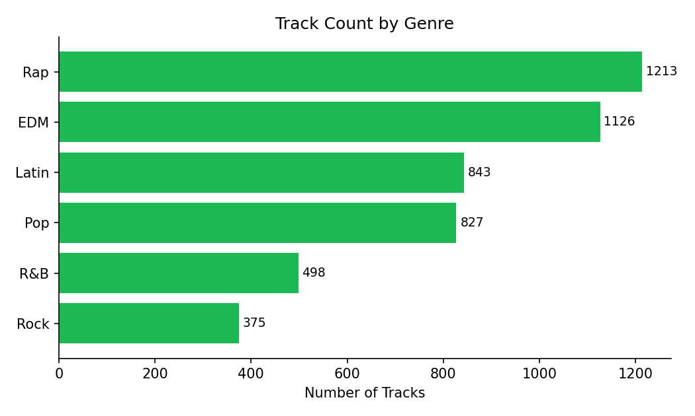
Figure 1. Track count by genre
INSIGHTS:
- Rap and EDM are the largest genres by track count, with 1,213 and 1,126 tracks respectively.
- Rock has the smallest release volume, with only 375 tracks in the six-month window.
- A wide gap between the top and bottom genres suggests the catalog window is weighted toward rap, EDM and Latin releases over rock.
- Genre-level track counts can help guide playlist-curation and release-scheduling decisions.
KPI:
Total tracks: 4,882
Total genres: 6
Largest genre: Rap (1,213 tracks)
Smallest genre: Rock (375 tracks)

4. Average Popularity Score by Genre
The overall average popularity score across the window is ~47.6 (out of 100). The chart below shows how average popularity varies by genre.
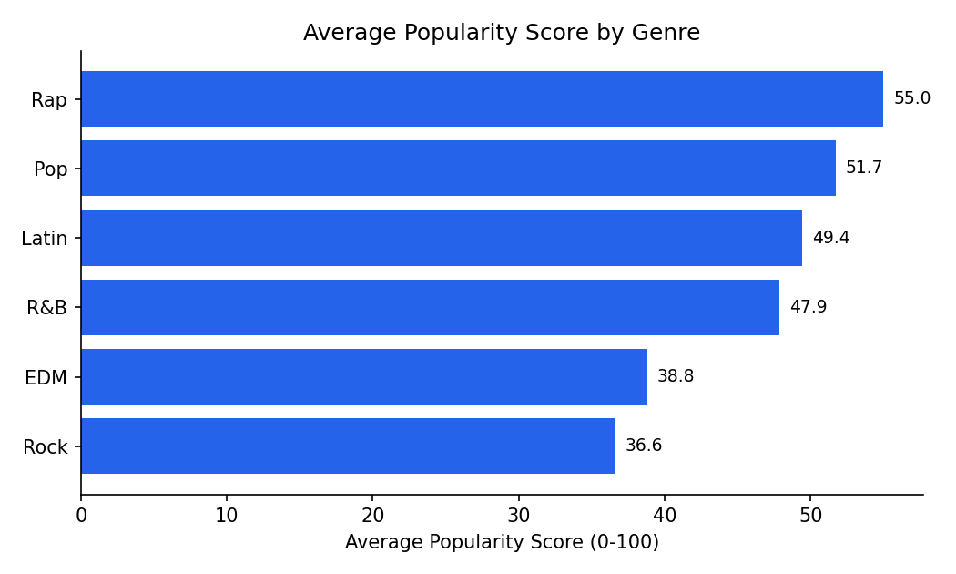
Figure 2. Average popularity score by genre
INSIGHTS:
- Rap carries the highest average popularity (54.98), followed by Pop (51.69).
- Rock and EDM carry the lowest average popularity, at 36.57 and 38.79 respectively.
- Popularity varies meaningfully by genre, which can inform genre-level curation and promotion strategy.
KPI:
Overall avg. popularity: ≈ 47.59
Overall median popularity: 47.00
Highest-popularity genre: Rap (≈ 54.98)
Lowest-popularity genre: Rock (≈ 36.57)

5. Average Danceability by Genre
The overall average danceability across the window is ≈67.4%. The chart below compares average danceability across genres.
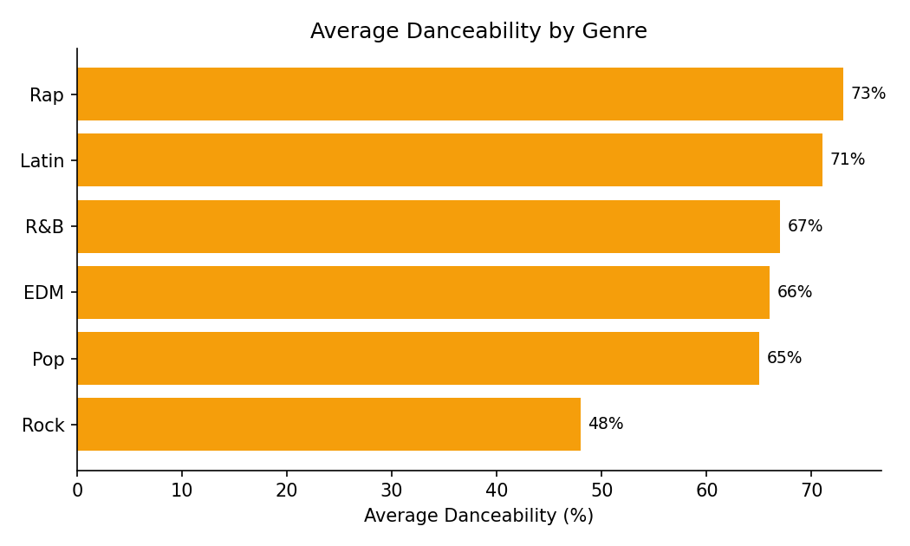
Figure 3. Average danceability by genre
INSIGHTS:
- Rap shows the highest average danceability (≈73%), consistent with its rhythm-driven, vocal-forward production.
- Rock shows the lowest average danceability (≈48%), reflecting its instrumental and guitar-driven norms.
- Danceability tracks fairly closely with the genres that also score highest on average popularity (Rap, Latin, Pop).
KPI:
Overall avg. danceability: ≈ 67.4%
Highest-danceability genre: Rap (≈73%)
Lowest-danceability genre: Rock (≈48%)

6. High-Popularity Rate by Genre
Of the 4,882 tracks, 1,158 (≈23.7%) reach the High or Very High popularity tiers (score ≥ 61). The chart below breaks this down by genre.
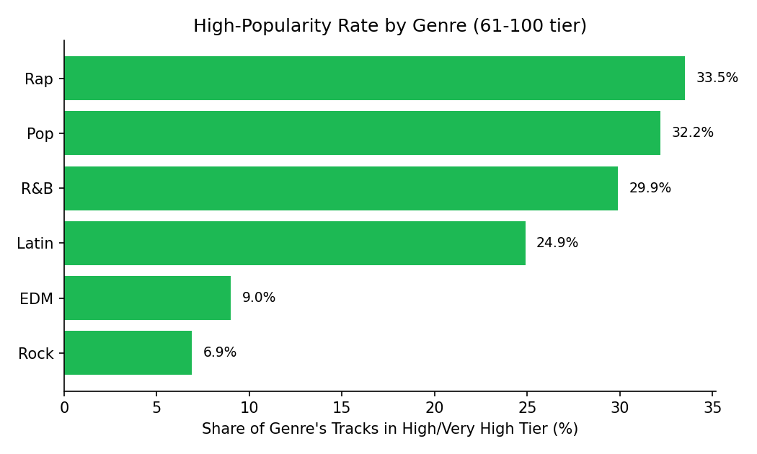
Figure 4. High-popularity rate by genre
INSIGHTS:
- Rap shows the highest breakout-hit rate in the window, at ≈33.5%.
- Pop and R&B follow closely, at ≈32.2% and ≈29.9% respectively.
- EDM and Rock show the lowest breakout-hit rates (≈9.0% and ≈6.9%), indicating these genres release a larger share of tracks that stay in the lower tiers.
- Genres with a low breakout-hit rate may need closer curation attention to surface their strongest tracks.
KPI:
Overall high-popularity rate: ≈ 23.7% (1,158 of 4,882 tracks)
Highest-rate genre: Rap (≈ 33.5%)
Lowest-rate genre: Rock (≈ 6.9%)

7. Overall Breakout-Hit Rate
Viewed at the catalog level (rather than by genre), roughly one in four tracks in the supplied window reached the High/Very High popularity tiers.
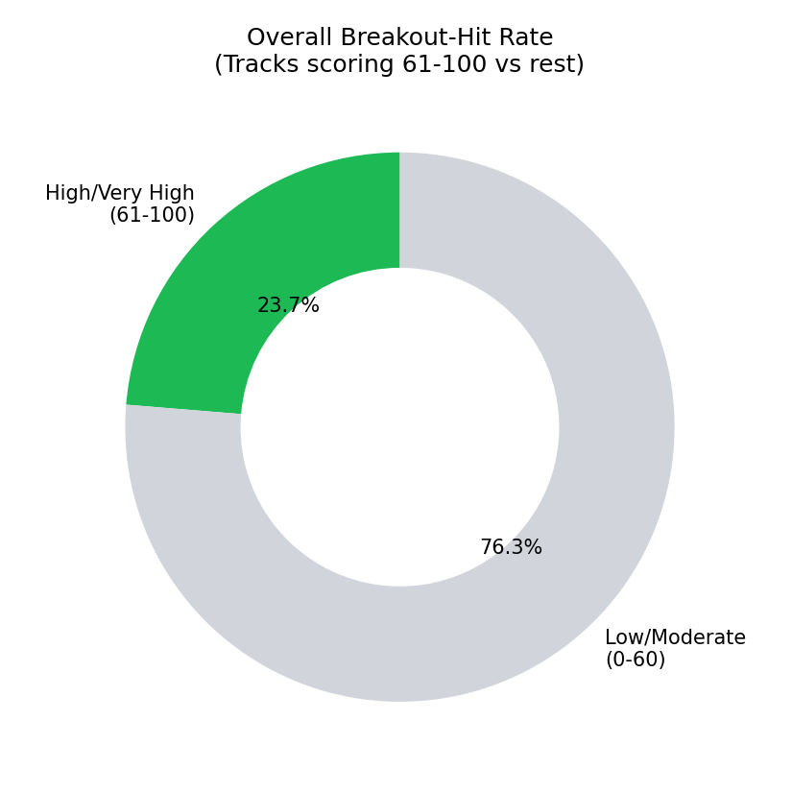
Figure 5. Overall breakout-hit rate
INSIGHTS:
- ≈23.7% of tracks in the window scored 61 or above, while ≈76.3% sat in the Low/Moderate range (0-60).
- A roughly one-in-four breakout rate is consistent with a long-tail pattern typical of streaming platforms.
- This KPI is best tracked over successive release windows rather than as a single-point snapshot.
KPI:
High/Very High (61-100): 1,158 tracks (≈ 23.7%)
Low/Moderate (0-60): 3,724 tracks (≈ 76.3%)

8. Popularity Score Distribution
The histogram below shows how popularity scores are distributed across the full six-month window.
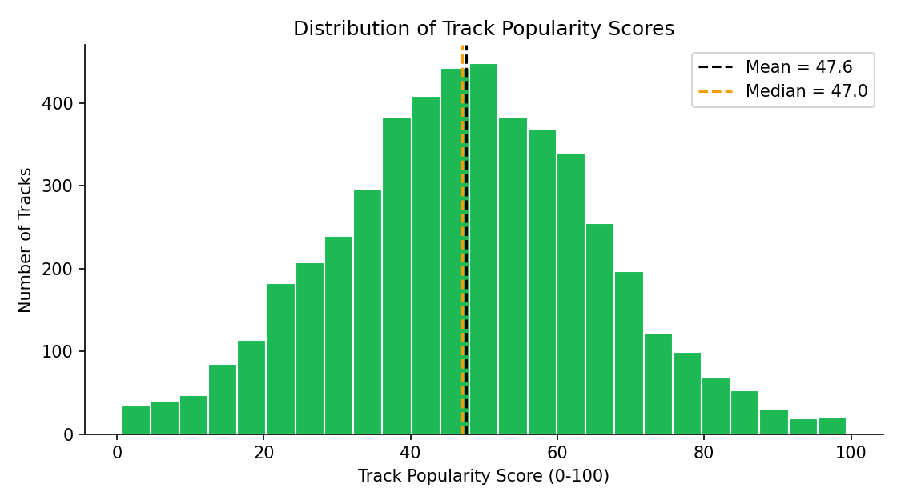
Figure 6. Distribution of popularity scores
INSIGHTS:
- The distribution is broadly bell-shaped with a long thin tail of very high-scoring breakout hits above 90.
- The median popularity (47.0) sits close to the mean (≈47.6), indicating a roughly symmetric middle of the distribution.
- This pattern is typical of a streaming catalog, where a large moderate-popularity middle tier surrounds a small number of viral outliers.
KPI:
Median popularity: ≈ 47.00
Mean popularity: ≈ 47.59
Standard deviation: ≈ 17.83
Maximum popularity: 100 (“Dance Monkey”)

9. Track Distribution by Popularity Band
To make the popularity distribution easier to act on, tracks are grouped into five tiers: Very Low (0-20), Low (21-40), Moderate (41-60), High (61-80) and Very High (81-100).
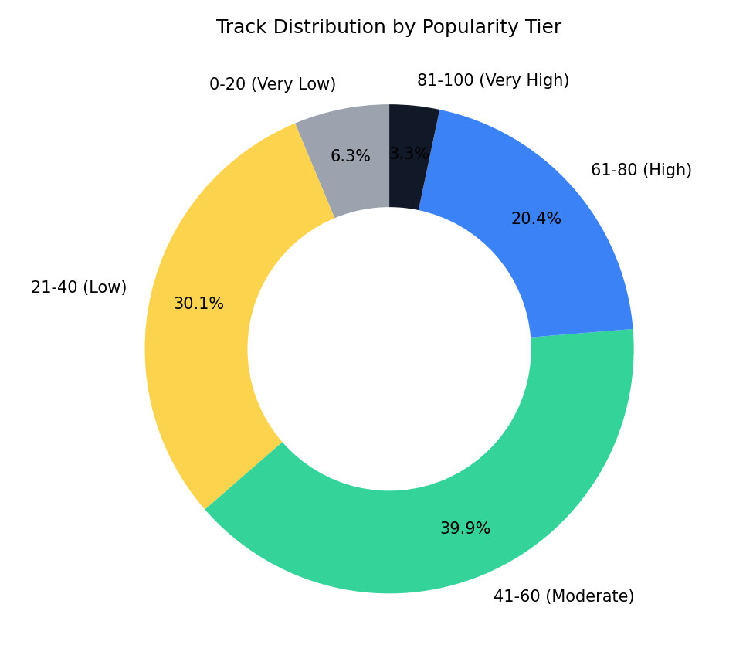
Figure 7. Track distribution by popularity tier
INSIGHTS:
- The Moderate band (41-60) is the largest, holding 1,947 tracks — ≈39.9% of the window.
- Low-tier tracks (21-40) make up the second-largest share at ≈30.1% (1,469 tracks).
- Very High-tier tracks (81-100) are a small minority at ≈3.3% (162 tracks), confirming that true breakout hits are rare.
- This banding can support tiered curation strategy — e.g., weighting playlists toward High/Very High tracks.
KPI:
Largest tier: Moderate (41-60) — 1,947 tracks, 39.9%
Smallest tier: Very High (81-100) — 162 tracks, 3.3%

10. Track Distribution by Duration Band
Tracks are further grouped by duration: Short (under 2.5 min), Standard (2.5-3.5 min), Long (3.5-4.5 min), and Extended (above 4.5 min).
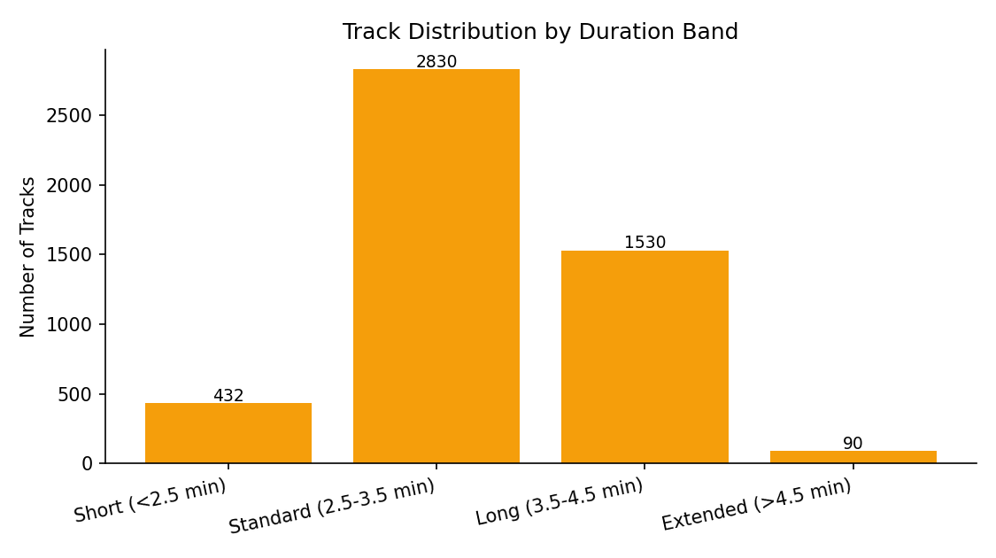
Figure 8. Track distribution by duration band
INSIGHTS:
- The Standard band (2.5-3.5 minutes) is the most common, covering the large majority of tracks in the window.
- Very few tracks fall in the Extended band (above 4.5 minutes), consistent with the well-documented industry shift toward shorter streaming-era songs.
- This distribution mirrors the reported mean duration of 3.27 minutes (median 3.20 minutes).
KPI:
Mean duration: ≈ 3.27 minutes
Median duration: ≈ 3.20 minutes

11. Danceability vs Popularity Relationship
The scatter plot below relates each track's danceability to its popularity score, colored by energy, to show how these audio features co-occur across the catalog.
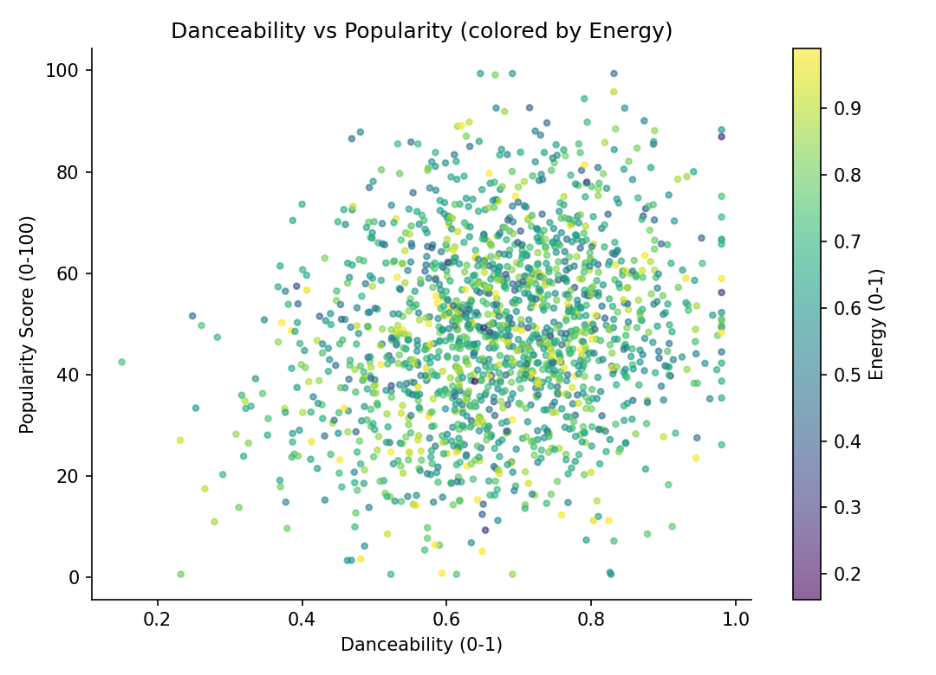
Figure 9. Danceability vs popularity, colored by energy
INSIGHTS:
- Popularity rises mildly with danceability (r ≈ 0.18), the strongest positive correlation among the audio features tested.
- Higher-energy tracks (lighter points) do not clearly cluster at higher popularity — energy shows a weak negative association overall (r ≈ –0.12).
- This view helps identify where danceable, high-popularity tracks are concentrated across the catalog.

12. Top 15 Most-Played Tracks
The table below lists the fifteen tracks with the highest popularity scores in the supplied window.
Rank | Track | Artist | Genre | Popularity | Release Date
1 | Dance Monkey | Tones and I | Pop | 100 | 2019-10-17
2 | ROXANNE | Arizona Zervas | Latin | 99 | 2019-10-10
3 | The Box | Roddy Ricch | Rap | 98 | 2019-12-06
4 | Tusa | KAROL G | Pop | 98 | 2019-11-07
5 | Memories | Maroon 5 | Pop | 98 | 2019-09-20
6 | Circles | Post Malone | Pop | 98 | 2019-09-06
7 | Blinding Lights | The Weeknd | Pop | 98 | 2019-11-29
8 | Don't Start Now | Dua Lipa | Pop | 97 | 2019-10-31
9 | everything i wanted | Billie Eilish | Pop | 97 | 2019-11-13
10 | RITMO (Bad Boys For Life) | The Black Eyed Peas | Pop | 96 | 2019-10-12
11 | Yummy | Justin Bieber | Pop | 95 | 2020-01-03
12 | My Oh My (feat. DaBaby) | Camila Cabello | Pop | 94 | 2019-12-06
13 | HIGHEST IN THE ROOM | Travis Scott | Pop | 94 | 2019-10-04
14 | hot girl bummer | blackbear | Pop | 94 | 2019-08-23
15 | Lose You To Love Me | Selena Gomez | Pop | 93 | 2019-10-23
INSIGHTS:
- “Dance Monkey” by Tones and I tops the list with the maximum possible score of 100, followed closely by “ROXANNE” (99) and “The Box” (98).
- Pop dominates the top-15 list with 13 of 15 entries, despite Rap having the higher average popularity overall — pop achieves more variance, including the window's single biggest outlier hit.
- The top tracks span the full window (August 2019 to January 2020), with no single month dominating the leaderboard.

13. Top 12 Most Prolific Artists
For context alongside the most-played tracks, the table below lists the twelve artists who released the most tracks in the window.
Artist | Tracks in Window | Primary Genre
Dimitri Vegas & Like Mike | 12 | EDM
Steve Aoki | 11 | EDM
Armin van Buuren | 11 | EDM
R3HAB | 10 | EDM
Post Malone | 10 | Pop
Camila Cabello | 10 | Pop
Lauv | 9 | Pop
Trippie Redd | 9 | Rap
Ozuna | 9 | Latin
Arcangel | 8 | Latin
Tiesto | 7 | EDM
Selena Gomez | 7 | Pop
INSIGHTS:
- Dimitri Vegas & Like Mike lead with 12 tracks in the window, followed by Steve Aoki and Armin van Buuren with 11 each — largely EDM DJs/producers who frequently release singles and remixes.
- High release volume does not guarantee high average popularity: several of the most prolific artists sit in EDM, the genre with the second-lowest average popularity score (38.79) in the sample.
- Volume and popularity are only loosely related at both the genre level and the individual-artist level.

14. Track Duration Distribution
The chart below shows how track duration (minutes) is distributed across the catalog window.
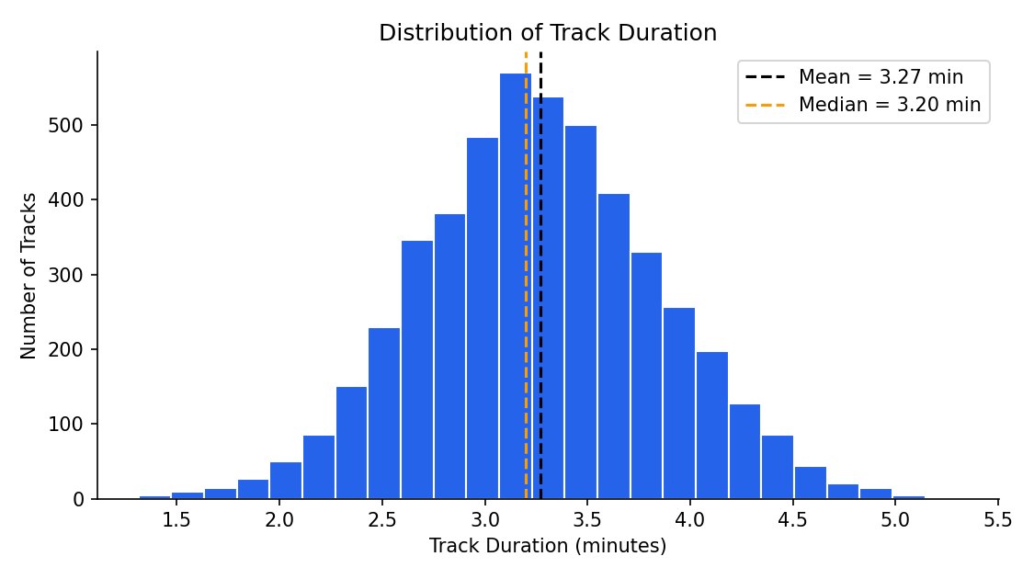
Figure 10. Distribution of track duration
INSIGHTS:
- Most tracks run between 2.5 and 4 minutes, consistent with streaming-era pack/duration norms.
- A smaller number of longer tracks (above 5 minutes) extend the tail of the distribution.
- Duration data can support playlist pacing and skip-rate planning alongside genre and popularity data.
KPI:
Median duration: ≈ 3.20 minutes
Mean duration: ≈ 3.27 minutes

15. Average Duration by Genre
The chart below compares average track duration across genres, giving a sense of which genres skew toward longer runtimes.
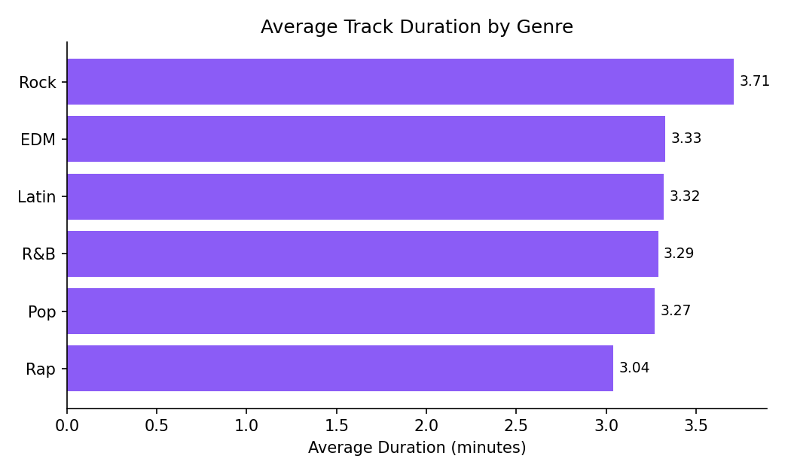
Figure 11. Average track duration by genre
INSIGHTS:
- Rock carries the longest average runtime (≈3.71 minutes), consistent with the genre's tradition of extended instrumental sections.
- Rap tracks are the shortest on average (≈3.04 minutes), a pattern widely attributed to streaming-era incentives that reward song length just long enough to count as a stream.
- Duration, genre and popularity are related: the shortest-running genre (rap) is also the highest-popularity genre.
KPI:
Longest genre (avg.): Rock (≈ 3.71 min)
Shortest genre (avg.): Rap (≈ 3.04 min)

16. Correlation of Audio Features with Popularity
To understand which audio characteristics move together with popularity, the chart below shows the correlation coefficient (r) between each audio feature and the track popularity score.
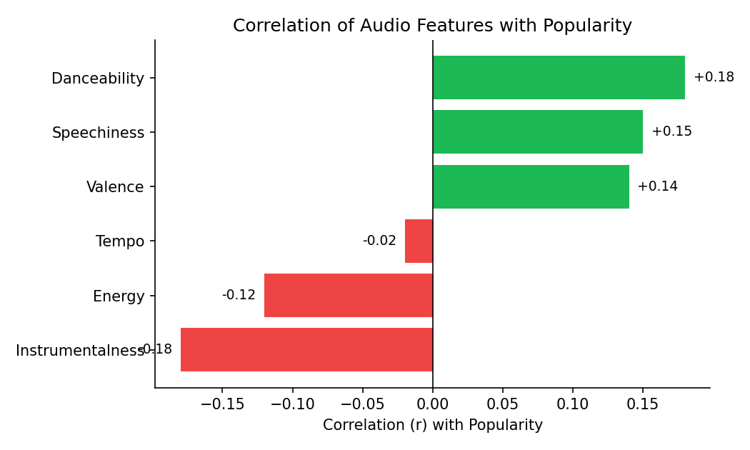
Figure 12. Correlation of audio features with popularity
INSIGHTS:
- Danceability (r ≈ 0.18), speechiness (r ≈ 0.15) and valence (r ≈ 0.14) show the strongest positive associations with popularity.
- Instrumentalness (r ≈ –0.18) and energy (r ≈ –0.12) show the strongest negative associations.
- Tempo shows essentially no linear association with popularity (r ≈ –0.02).
- These are descriptive associations only — none of the coefficients are strong enough to support a predictive claim on their own.

17. Cumulative Popularity Contribution by Genre
Summing each track's popularity score by genre gives an estimate of cumulative popularity contribution — useful for understanding which genres drive the most total listening interest, as distinct from average popularity per track.
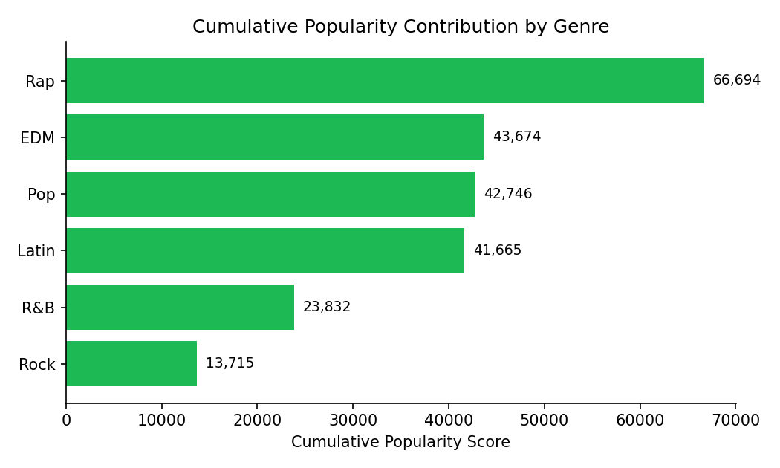
Figure 13. Cumulative popularity contribution by genre
INSIGHTS:
- Rap contributes the most cumulative popularity (66,694), consistent with its combination of high track volume and high average popularity.
- EDM contributes more cumulative popularity than its average-popularity ranking alone would suggest (43,674), reflecting its high track volume rather than high per-track quality.
- Rock contributes the least cumulative popularity (13,715), driven by both its small track count and its low average popularity.
KPI:
Total cumulative popularity: 232,326 across the catalog
Top contributor: Rap (66,694)
Lowest contributor: Rock (13,715)

18. Low-Popularity Tracks by Genre
Tracks scoring 0-20 (the Very Low tier) represent releases that gained little to no traction in the window. The chart below shows how many such tracks exist per genre.
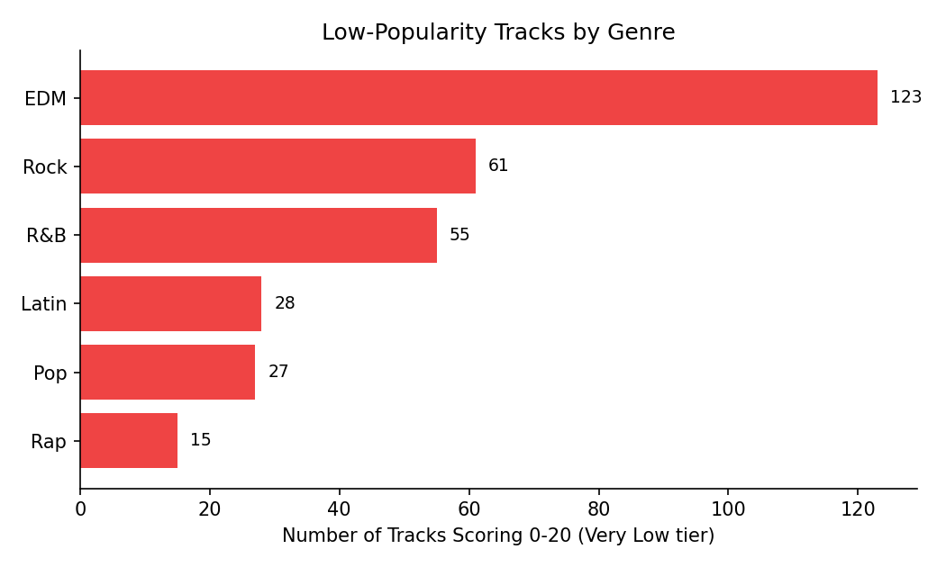
Figure 14. Low-popularity tracks by genre
INSIGHTS:
- 308 tracks — roughly 1 in 16 of the catalog window — scored in the Very Low (0-20) tier.
- EDM accounts for the largest share of low-popularity tracks (≈123), mirroring its large release volume.
- Rap shows the fewest low-popularity tracks (≈15), reflecting its tight concentration of tracks in the Moderate-to-High tiers.
- This list is a natural candidate for a review of release/promotion strategy, since these tracks gained the least traction despite being part of a major-label release cycle.
KPI:
Tracks in Very Low tier (0-20): 308 (≈ 6.3% of window)
Highest-risk genre: EDM (≈123 tracks)

19. Monthly Release Trend
Because each track carries an album release date, monthly release volume and average popularity can be tracked across the six-month window.
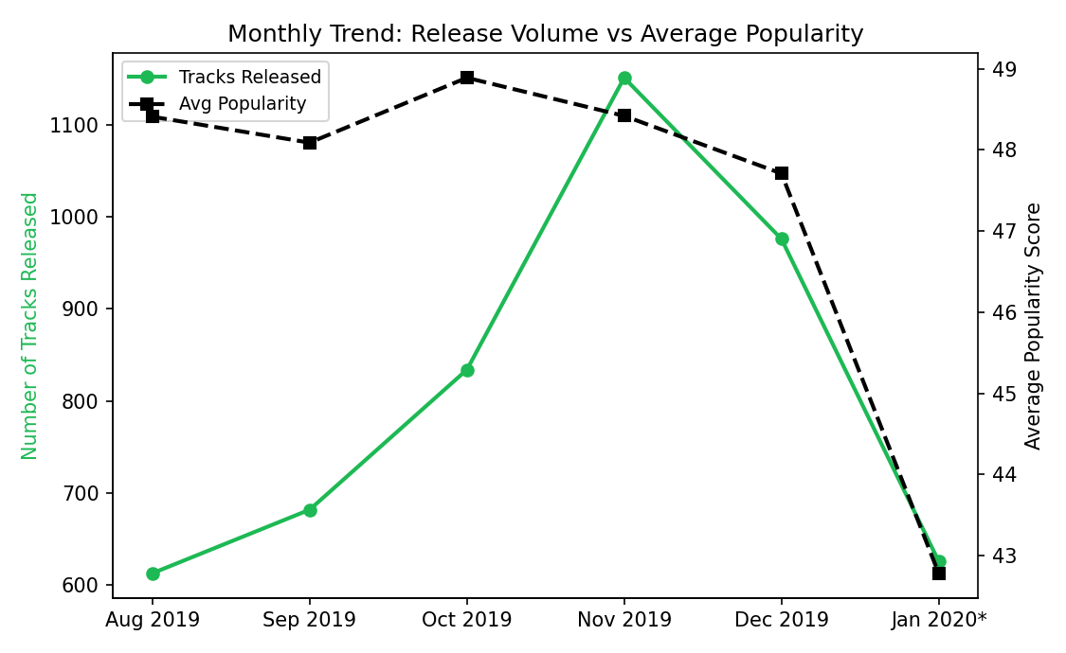
Figure 15. Monthly release volume vs average popularity
INSIGHTS:
- Release volume rose steadily from 613 tracks in August 2019 to a peak of 1,151 tracks in November 2019 — likely reflecting the industry's pre-holiday release push.
- Average popularity stayed remarkably stable, in the high 47-to-49 range, for the first five months, then dropped to 42.8 in January 2020, the lowest average of the window.
- January 2020 is a partial month (data collected through 29 January), and newer releases have had less time to accumulate streams — both likely contribute to the lower reading.
KPI:
Peak release month: November 2019 (1,151 tracks)
Lowest avg. popularity month: January 2020† (42.78)

20. Genre Share of Total Popularity
Viewing cumulative popularity as a share of the whole catalog window complements the per-track averages in Section 4 with a volume-weighted view.
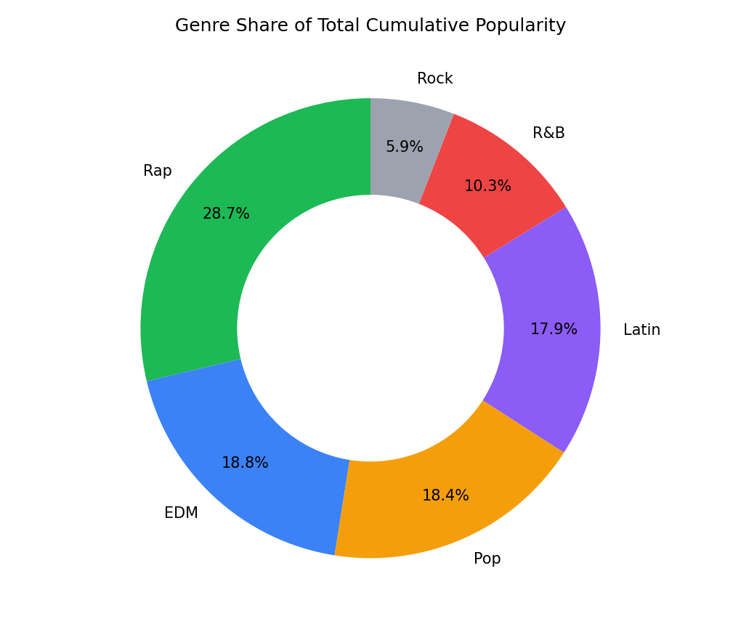
Figure 16. Genre share of total cumulative popularity
INSIGHTS:
- Rap accounts for the largest share of total catalog popularity (≈28.7%), consistent with its high SKU-equivalent track count and above-average popularity per track.
- Rock contributes the smallest share (≈5.9%), reflecting both its small track count and its lower average popularity.
- This volume-weighted view is useful for prioritising which genres matter most to overall catalog performance, as opposed to per-track averages alone.

Summary of Key Metrics
Metric | Value
Total tracks | 4,882
Genres tracked | 6
Overall avg. popularity | ≈ 47.59
Overall median popularity | 47.00
Overall avg. danceability | ≈ 67.4%
High/Very High-tier tracks (61-100) | 1,158 (≈ 23.7%)
Very Low-tier tracks (0-20) | 308 (≈ 6.3%)
Median track duration | ≈ 3.20 minutes
Peak release month | November 2019 (1,151 tracks)
Top genre by cumulative popularity | Rap (66,694)

Next Steps to Move from Descriptive → Predictive
- Popularity forecasting by genre and release month once continuously-updated stream data is available.
- Breakout-hit prediction using audio-feature and release-timing patterns to flag tracks likely to reach the Very High tier early.
- Playlist/curation optimization linking genre and tier composition to actual listener engagement, once session-level data is added.
- Artist-cohort analysis once longer historical release windows become available.
- Cross-platform comparison (Spotify vs Apple Music, YouTube Music) once equivalent external data is accessible.
This report answers what the supplied catalog window looked like across August 2019-January 2020. The next analytical layer would combine this track-level data with continuous stream/engagement data to explain why popularity and genre patterns occur, and to forecast what is likely to happen next.

Glossary
Popularity score — Spotify's own 0-100 measure of how heavily a track is currently being streamed relative to all other tracks.
Danceability — A 0-1 Spotify audio feature describing how suitable a track is for dancing, based on tempo, rhythm stability, beat strength and overall regularity.
Energy — A 0-1 perceptual measure of intensity and activity in a track.
Valence — A 0-1 measure of the musical positiveness conveyed by a track.
Popularity tier — A grouping of tracks into five bands (Very Low, Low, Moderate, High, Very High) based on popularity score.
Breakout hit — A track reaching the High or Very High popularity tier (score ≥ 61).
Genre — A broad grouping of tracks (Pop, Rap, Rock, Latin, R&B, EDM) used for catalog organization and reporting.

